KAR-MEN PHANG
Digital Marketing Portfolio
Malaysia & Singapore · Social Media · Email · Funnels · Content
karmenphang2@gmail.com · +60 11-1635 0635
linkedin.com/in/va-karmenphang
Available to start immediately

About
I'm a digital marketing specialist who turns everyday small-business moments — a salon appointment, a hawker-style dinner, a listing walkthrough — into campaigns that actually get looked at twice.
Over the past few years I've planned social calendars, written email flows, mapped funnels, and built CRM pipelines for brands across beauty, food & beverage, e-commerce, and real estate in Malaysia and Singapore. I design in Canva, edit in CapCut, generate creative with Higgsfield, and think out loud with Claude and ChatGPT — using AI to move faster without losing the craft.
Every project in this book is clearly labeled as a Concept Project / Portfolio Demonstration — built to show how I think and execute, not to claim real client results I haven't earned yet.

Services
Social Media Management
Content pillars, calendars, and on-brand visual systems that keep a feed consistent — and worth following.
Email Marketing & Automation
Lifecycle flows — welcome, abandoned cart, win-back — built to turn one-time buyers into repeat customers.
Funnel & Landing Page Strategy
Offer-to-checkout journeys mapped end to end, from ad hook to retargeting sequence.
Content Creation
Short-form video, carousels, and copy — planned, designed, and edited for how people actually scroll.
Lead Generation & CRM Setup
HubSpot pipelines and follow-up cadences that stop hot leads from going cold.
AI-Accelerated Production
Claude, ChatGPT & Higgsfield woven into the workflow for faster ideation, copy, and visual concepting.

Case Studies
8 concept projects across beauty, food & beverage, e-commerce, and real estate — each an honest Concept Project / Portfolio Demonstration.

VELVET & VINE SALON
Social Media Growth System · Beauty & Wellness

Social Media · Branding · Content Creation
OBJECTIVE
Build a cohesive Instagram presence that converts local followers into booked appointments.
PROBLEM
Inconsistent posting, no visual identity, and no repeatable content system.
MY ROLE
Sole social media strategist & content designer.
TOOLS USED
Canva, Notion, CapCut, Claude, Google Analytics
DELIVERABLES
Instagram feed grid concept, story highlight covers, promotional carousel set, Reels concept scripts, content calendar template.
RESULTS: Concept Project — built as a portfolio demonstration. No live client data to report.

HAWKER & HEARTH
Content & Social Concept · Food & Beverage — Singapore
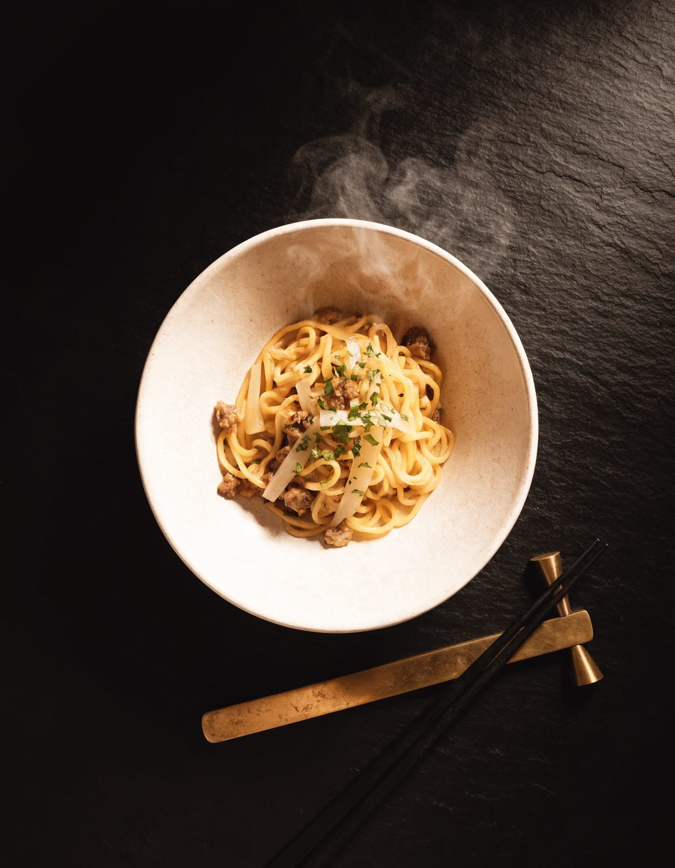
Social Media · Content Creation · Advertising
OBJECTIVE
Position a modern hawker-inspired café as a must-visit spot for locals and tourists alike.
PROBLEM
Strong food, weak online storytelling — no consistent short-form video presence.
MY ROLE
Content strategist & video editor.
TOOLS USED
CapCut, Canva, Higgsfield, Notion
DELIVERABLES
Reels/TikTok concept series, feed grid plan, caption bank, content pillars document.
RESULTS: Concept Project — built as a portfolio demonstration. No live client data to report.

TIDES SEAFOOD TABLE
Email Lifecycle & Retention Concept · Food & Beverage — Singapore
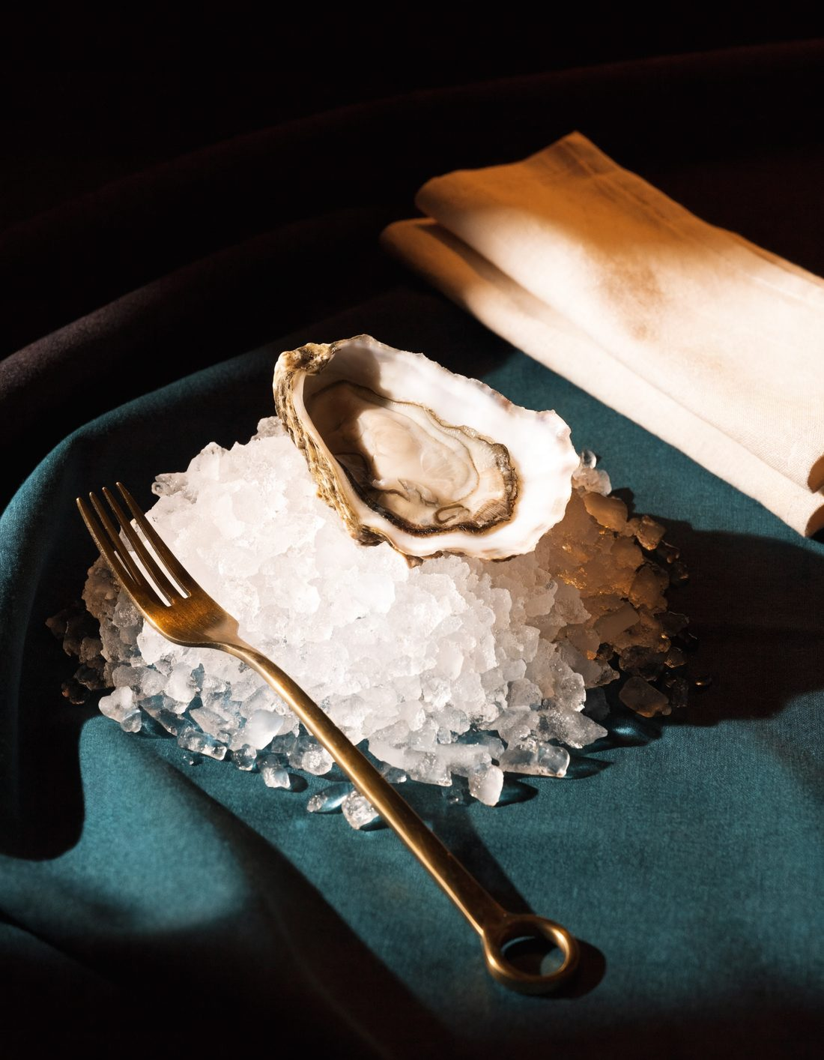
Email Marketing · Automation · CRM
OBJECTIVE
Turn one-time diners into repeat guests through structured email marketing.
PROBLEM
Reservation and feedback data was collected but never used for follow-up.
MY ROLE
Email marketing & automation designer.
TOOLS USED
Mailchimp, Canva, HubSpot, Claude
DELIVERABLES
3 automated email flows (welcome, birthday, win-back), segmented list architecture, branded email template set.
RESULTS: Concept Project — built as a portfolio demonstration. No live client data to report.

LUMEN SKINCARE CO.
Paid Acquisition Funnel Concept · E-Commerce — Beauty

Funnels · Advertising · Analytics
OBJECTIVE
Design a full acquisition funnel for a new skincare product launch.
PROBLEM
Good product-market fit but no structured funnel — traffic wasn't converting.
MY ROLE
Funnel strategist & landing page designer.
TOOLS USED
Canva, Google Analytics, Notion, ChatGPT
DELIVERABLES
Funnel map, landing page design concept, ad creative set, retargeting sequence outline.
RESULTS: Concept Project — built as a portfolio demonstration. No live client data to report.

NORTHWOOD HOME GOODS
Email & CRM Automation Concept · E-Commerce — Home Goods

Email Marketing · CRM · Automation
OBJECTIVE
Increase repeat purchase rate through automated, behavior-triggered email flows.
PROBLEM
A real customer list existed but was never segmented or nurtured.
MY ROLE
CRM & email automation specialist.
TOOLS USED
Mailchimp, HubSpot, Google Analytics, Notion
DELIVERABLES
4 automated email flows, segmentation framework, monthly newsletter template.
RESULTS: Concept Project — built as a portfolio demonstration. No live client data to report.

AERO ACTIVEWEAR
Brand & Content System Concept · E-Commerce — Apparel

Content Creation · Social Media · Branding
OBJECTIVE
Build a scroll-stopping brand identity and content system for a DTC activewear launch.
PROBLEM
Generic product photography, no defined brand voice, no content variety.
MY ROLE
Brand & content designer.
TOOLS USED
Canva, Higgsfield, CapCut, Notion, Claude
DELIVERABLES
Brand style guide snapshot, Instagram feed concept, product launch carousel set, UGC-style video concepts.
RESULTS: Concept Project — built as a portfolio demonstration. No live client data to report.

MARINA PRIME PROPERTIES
Lead Generation & CRM Concept · Real Estate — Singapore

Lead Generation · CRM · Digital Marketing
OBJECTIVE
Build a structured lead capture and nurture system for a boutique property agency.
PROBLEM
Leads arrived through scattered channels with no central tracking.
MY ROLE
Lead generation & CRM strategist.
TOOLS USED
HubSpot, Zillow, Canva, Google Analytics, Notion
DELIVERABLES
Lead capture landing page concept, HubSpot pipeline structure, follow-up sequence, market comps one-pager.
RESULTS: Concept Project — built as a portfolio demonstration. No live client data to report.

ORCHARD ESTATE GROUP
Listing Marketing & Video Concept · Real Estate — Singapore

Social Media · Content Creation · Digital Marketing
OBJECTIVE
Make a high-value residential listing feel premium and shareable across social channels.
PROBLEM
Listings were marketed with flat, spec-sheet style photos only.
MY ROLE
Content & social strategist.
TOOLS USED
Higgsfield, CapCut, Canva, Zillow, Claude
DELIVERABLES
Listing carousel set, teaser video concept, story sequence, narrative property description.
RESULTS: Concept Project — built as a portfolio demonstration. No live client data to report.

Capability Statement
Kar-Men Phang is a Malaysia-based digital marketing specialist providing social media, email marketing, funnel strategy, and content production support to hospitality, retail, e-commerce, and real estate businesses across Malaysia and Singapore.
CORE COMPETENCIES
- Social Media Strategy & Content Systems
- Email Marketing & Lifecycle Automation
- Funnel Mapping & Conversion Strategy
- Short-Form Video & Visual Content Production
- CRM Pipeline & Lead Generation Setup
- AI-Augmented Creative Workflows
DIFFERENTIATORS
- Cross-market fluency across Malaysia and Singapore consumer behavior
- Hands-on execution across the full stack — strategy, design, copy, and CRM — not just one slice of the funnel
- Early, practical adoption of AI tools (Claude, ChatGPT, Higgsfield) to compress production timelines
TOOLS
Canva, CapCut, Higgsfield, HubSpot, Mailchimp, Google Analytics, Zillow, Notion, Claude, ChatGPT
CONTACT
karmenphang2@gmail.com · +60 11-1635 0635 · linkedin.com/in/va-karmenphang

Service Packages
Social Starter — For brands that need a consistent, professional feed
- Monthly content calendar & pillars
- 12 designed posts / month (Canva)
- Caption writing & hashtag strategy
- 1 platform (IG or FB)
Growth Engine — For brands ready to convert followers into customers (Most Popular)
- Everything in Social Starter
- 2 platforms + Reels/short-form video
- Email welcome & nurture flow (Mailchimp)
- Monthly performance snapshot (Google Analytics)
Full Funnel Partner — For brands that want a hands-off marketing partner
- Everything in Growth Engine
- Funnel & landing page strategy
- CRM pipeline setup (HubSpot)
- Lead follow-up sequences
- Quarterly strategy review

